TIENDA DE ORDENADORES

- Realizar una aplicación para poder calcular los precios y las compras de un formulario.

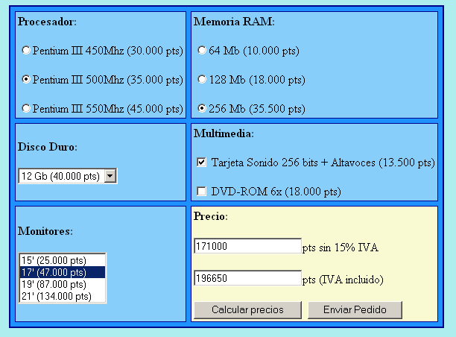

<!DOCTYPE html>
<!--
To change this license header, choose License Headers in Project Properties.
To change this template file, choose Tools | Templates
and open the template in the editor.
-->
<!DOCTYPE html PUBLIC "-//W3C//DTD HTML 4.01//EN"
"http://www.w3.org/TR/html4/strict.dtd">

<html xmlns="http://www.w3.org/1999/xhtml" lang="en">
<head>
<meta http-equiv="Content-Type" content="text/html; charset=utf-8" />
<title>Ejemplos JavaScript</title>
<meta name="author" />
<style>
.estilo1{
font-family: Verdana;
color: #0099ff;
}

.estilo2{
font-family: Arial;
color: #ffffff;
}

.estilo3{
font-family: Verdana;
color: red;
}
.estilo8{
border: #F2BE84 5px solid;
font-family: sans-serif;
color: blue;
background: blue;
}

.estilo4{
border: #F2BE84 5px solid;
font-family: sans-serif;
color: blue;
background: #D0D0D0;
}

.estilo5{
font-family: Georgia;
color: blue;
}

.estilo6{
font-family: Helvetica;
color: fuchsia;
}
</style>
<script type="text/javascript" src="jquery-1.10.2.js"></script>
<script>
function calcularPrecios(){

var salario=0;

$("select").each(function(){
var num1 = parseInt($(this).val());
salario = salario +num1;
});

$("input[type=checkbox]:checked").each(function(){
var num2 = parseInt($(this).val());
salario = salario +num2;
});

$("input[type=radio]:checked").each(function(){
var num3 = parseInt($(this).val());
salario = salario +num3;
});
$("#siniva").val(salario);
$("#coniva").val(salario+salario*21/100);
}

</script>
</head>

<table class="estilo4">
<tr>
<td> <fieldset>
<div id="titulo1" >Procesador</div>

<input type="radio" value="30000" name="rdbestilos2">Pentium III 450 Mhz<br>
<input type="radio" value="35000" name="rdbestilos2">Pentium III 500 Mhz<br>
<input type="radio" value="40000" name="rdbestilos2">Pentium III 550 Mhz<br>
</fieldset></td>

<td><fieldset class="estilo4">
<div id="titulomonitores" >Memoria RAM</div>
<form name="form2" >
<input type="radio" value="10000" name="rdbestilos">64 Mb (10.000 pts)<br>
<input type="radio" value="18000" name="rdbestilos">128 Mb (18.000 pts)<br>
<input type="radio" value="35000" name="rdbestilos">256 Mb (35.000 pts)<br>
</form>
</fieldset></td>
</tr>
<tr>

<td><fieldset>
<div id="titulodisco" >Disco Duro</div>
<select id="selectmodelodisco" >
<option value="40000">12 Gb</option>
<option value="50000">24 Gb</option>
<option value="60000">48 gb</option>
<option value="70000">64 gb</option>
</select>
</fieldset></td>

<td><fieldset>
<div id="tituloMultimedia" >Multimedia</div>
<form name="form3">
<input type="checkbox" value="13500" name="chkcompra">Tarjeta de sonido 256 bits + Altavoces<br>
<input type="checkbox" value="18000" name="chkcompra">DVD-ROM 6x<br>
</fieldset></td>

</tr>
<tr>

<td><fieldset>
<div id="titulomonitores" >Monitores</div>
<select id="selectmodelomonitor" size="4" >
<option value="25000">15'(25.000 pts)</option>
<option value="47000">17' (47.000 pts)</option>
<option value="87000">19' (87.000 pts) </option>
<option value="134000">21' (134.000 pts) </option>
</select>
</fieldset></td>

<td><fieldset>
<legend>Precio sin IVA</legend>
<input type="text" id="siniva" readonly>
<br>
</fieldset>

<fieldset>
<legend>Precio con IVA</legend>
<input type="text" id="coniva" readonly>
<br>
</fieldset>

<fieldset>
<input type="button" value="Calcular precios" onclick="calcularPrecios()">
<br>
<input type="button" value="Enviar pedido" >
</fieldset>
</td>
</tr>

</table>
</body>
</html>

